ve

* **Central Equipment Identity Register System Admine Portal**

**System Admin User Manual v 2.1**

Document Change History

|  |  |  |  |
| --- | --- | --- | --- |
| Version | Change Type | Description | Date |
| Draft |  | Submitted for internal review | February 2020 |
| Version 2.1 |  | Multiple System Admin, Configurable Notifications, Filter and sorting, Field Validations, History of the request, Address management | June 2021 |

Contents

1 Overview 1

1.1 Scope 1

1.2 Acronyms & Abbreviations 1

1.3 Conventions 1

2 System Admin Operations 2

2.1 Application Overview 2

2.2 Logging into the Application 2

2.3 Application User Interface 5

2.4 System Management 7

2.5 Edit Parameter 8

2.6 Filter Parameter 9

2.7 Message Management 10

2.8 Edit Message 11

2.9 Filter Message 12

2.10 Custom Port 12

2.11 Edit Port Parameters 13

2.12 Filter Custom Port 14

2.13 Field Management 15

2.14 Edit Field Parameters 17

2.15 Filter Field Management 17

2.16 Add new field in Field Management 18

2.17 Exchange Rate Management 19

2.18 Edit Exchange Rate Parameters 20

2.19 Filter Currency Management 21

2.20 Add Currency Management 22

2.21 Audit Management 23

2.22 Filter Audit Management 24

2.23 User Type Management 25

2.24 Edit User type 26

2.25 Filter User Type Management 27

2.26 Rule List 27

2.27 Edit Rule List 28

2.28 Filter Rule list 29

2.29 User Feature Mapping 30

2.30 Edit user feature mapping 31

2.31 Filter User Feature Mapping 31

2.32 Rule Feature Mapping 32

2.33 Edit Rule Feature Mapping 33

2.34 Filter Rule Feature Mapping 34

2.35 User Management 35

2.36 Edit Users information 36

2.37 Filter Users 37

2.38 Address Management 37

2.39 Edit Address details 38

2.40 Filter Address Management 39

2.41 DB Tables 40

2.42 Annex 1 41

2.43 Annex 2 46

2.44 Annex 3 50

2.45 Annex 4 56

Figures

Figure 1: Login 3

Figure 2: Home Page 4

Figure 3: Forgot Password 4

Figure 4: Set New Password 5

Figure 5: Home Page 5

Figure 6: View profile Information 6

Figure 7: Change Password 6

Figure 8: System Management – View All 7

Figure 9: System Management - Edit 9

Figure 10: System Management – Filter Option 9

Figure 11: System Management – View All 10

Figure 12: Message Management - Edit 11

Figure 13: Message Management – Filter Option 12

Figure 14: Custom Port – View All 13

Figure 15: Custom Port - Edit 14

Figure 16: Custom Port – Filter Option 14

Figure 17: Field Management 15

Figure 18: Field Management – View All 16

Figure 19: Field Management - Edit 17

Figure 20: Field Management – Filter Option 17

Figure 21: Field Management – Add new field 18

Figure 22: Field Management – Add Value Option 18

Figure 23: Exchange Rate Management – View All 19

Figure 24: Currency Management - Edit 20

Figure 25: Field Management – Filter Option 21

Figure 26: Field Management – Filter Option 22

Figure 27: Currency Management – Add Option 22

Figure 28: Audit Management – View All 23

Figure 29: Audit Management – Filter Option 24

Figure 30: Policy Management – View All 25

Figure 31: User Type Management - Edit 26

Figure 32: User Type Management – Filter Option 27

Figure 33: Rule List – View All 28

Figure 34: Rule List- Edit 29

Figure 35: Rule List – Filter Option 29

Figure 36: User Feature Mapping – View All 30

Figure 37: User Feature Mapping - Edit 31

Figure 38: User Feature Mapping – Filter Option 31

Figure 39: Rule Feature Mapping – View All 32

Figure 40: Rule Feature Mapping - Edit 34

Figure 41: Rule Feature Mapping – Filter Option 34

Figure 42: User Management – View All 35

Figure 43: User Management - Edit 36

Figure 44: User Management – Filter Option 37

Figure 45: Address Management – View All 38

Figure 46: Address Management - Edit 39

Figure 47: Address Management – Filter Option 39

Figure 48: DB Tables 40

Figure 49: DB Tables – view specific table 40

# Overview

## Scope

The objective of this manual is to help system admin to use and configure the CEIR (Central Equipment Identity Register) application.

## Acronyms & Abbreviations

| **Acronym** | **Full Form** |
| --- | --- |
| CEIR | Central Equipment Identity Register |
| IMEI | International Mobile Equipment Identity |
| PDA | Personal Digital Assistant |
| TAC | Type Allocation Code |
| TRC | Telecommunication Regulator of Cambodia |

## Conventions

| **Information** | **Convention** |
| --- | --- |
| UI elements  (such as names of windows, buttons, and fields) | Bold |
| References  (such as names of files, sections, paths, and  parameters) | *Italics* |
| **\*** | Indicates a mandatory field or column |

# System Admin Operations

## Application Overview

The CEIR (Central Equipment Identity Register) System Admin Portal is used to use and configure the CEIR application

System Admins perform the following tasks:

* Message Administration
* System Management
* Audit Management
* Custom Port
* Field Management
* Exchange Rate Management
* User type Management
* Rule list
* User Feature Mapping
* Rule Feature Mapping
* User Management
* Address Management

## Logging into the Application

As part of configuration, system admin login would be provided. The user’s name is ‘***system***’ and password is ‘***system***’. It is advised to change the password.

In case there is a need to register more than one system admin users, the same can be done using the user management feature in system admin portal.

To login:

1. Open the browser and enter the CEIR System Admin Portal URL in the address bar. The login screen appears.

Figure 1: Login

On the top right corner of the login screen is the **Language** option. The application supports two languages: **English** and **Khmer**. On selecting a given language, all the field and column labels in the application appear in the selected language. All user inputs are, however, in English.

1. Next, enter the assigned login username and password.

Username is the registration ID that is sent on mail to the System Admin after successful registration in the system.

1. Enter the captcha.
2. Click **LOGIN**.

If the login and password are incorrect or the captcha is not correct, an error message appears, and you are prompted to re-enter the login details.

On entering correct information, the application home page appears.

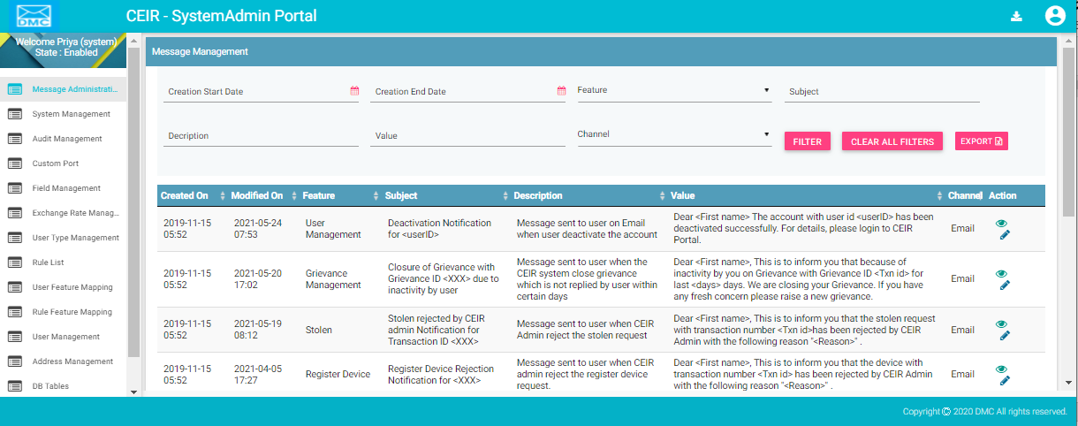

Figure 2: Home Page

If the System Admin forgets the assigned password, click the **Forgot Password** link on the **Login** page. The **Forgot Password** page appears.

Figure 3: Forgot Password

1. Enter the login username.
2. Select a security question from the list. Select any one of the security questions that were selected during registration.
3. Enter the answer to the selected security question. This should match the answer given at the time of registration.
4. Click **SUBMIT**.

The **Set New Password** page appears.

Figure 4: Set New Password

1. Enter a new password. Click  to see the password characters being entered. Click on it again to hide the password characters. This works like a toggle key.
2. Re-enter the password.
3. Click **Save**

## Application User Interface

On logging into the application successfully, the CEIR System Admin Portal home page appears. By default, the system management page opens up.

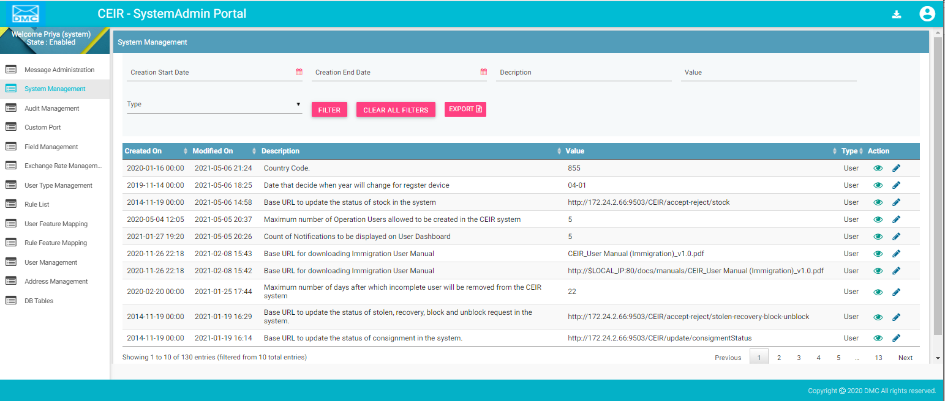

Figure 5: Home Page

The Home page has all the feature menus on the left panel.

The center of the page is the Dashboard.

The top right corner of the screen displays the following menu options:

* **Download**: Click to download this user manual.
* A close up of a logo

  Description automatically generated(**User profile**): Click on it to see the following menu:

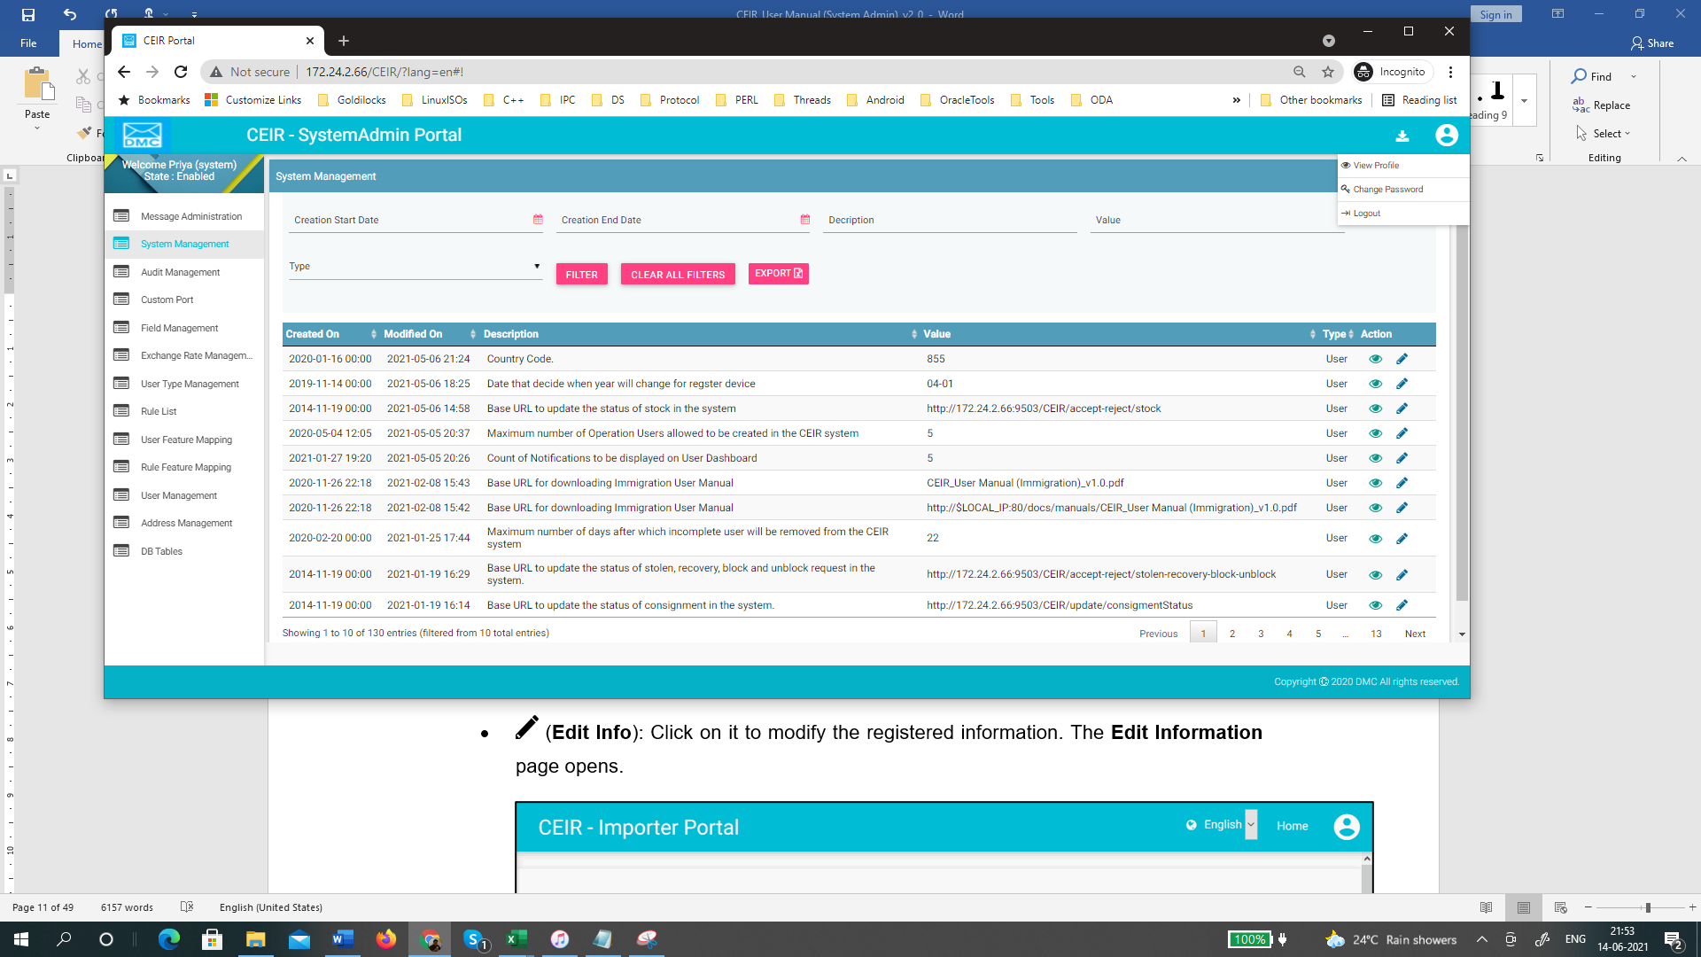

* (**View Profile**): Click on it to view the registered information. The **View Profile** page opens.

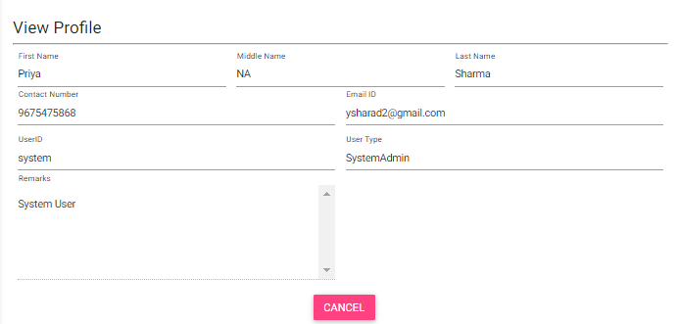

Figure 6: View profile Information

*  (**Change Password**): Click on it change the login password.

Figure 7: Change Password

1. **Old Password**: Enter the existing password. Click  to see the password characters being entered. Click on it again to hide the password characters. This works like a toggle key.
2. **New Password**: Enter a new password.
3. **Confirm Password**: Re-enter the new password to confirm the password.
4. Click **SUBMIT**.

## System Management

Using this feature, System admin can configure the system parameters. There are two types of parameters:

* System
* User

System parameter are not allowed to be changed and are configured at the time of installation.

User parameter can be changed by system admin. The parameter would come into effect from the next time the new request are processed.

.

To configure parameters:

1. Select **System Management** in the left panel.

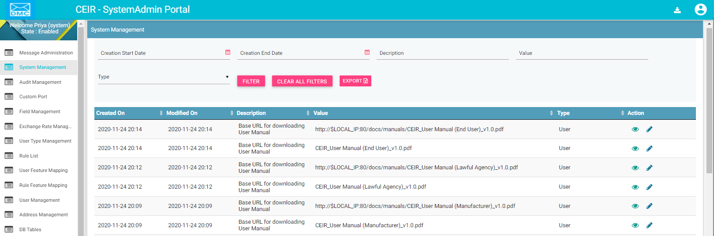

Figure 8: System Management – View All

The following columns are seen in the System Management Page

| **Column** | **Description** |
| --- | --- |
| Created On | This is the date of installation of system. |
| Modified On | Date when parameter is last modified. |
| Description | Description of the parameter. |
| Value | Current Value assigned to the parameter. |
| Type | Whether the parameter is of System or User Type |
| Action | This displays different actions that can be performed on the parameter.   * View : This is used to view the parameter details. * Edit A close up of a logo    Description automatically generated: This is used to modify the parameter details. |

Refer to Annex 1 for complete list of messages.

## Edit Parameter

System Admins can modify the parameter of type user.

To edit parameter:

1. Click **Edit (A close up of a logo

   Description automatically generated)** against the parameter entry to be modified.
2. The **Edit User Parameter** page appears.

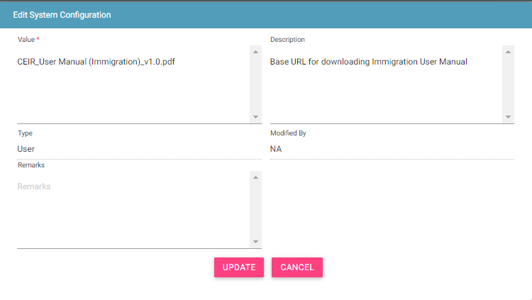

Figure 9: System Management - Edit

1. Make the required changes.
2. Click **UPDATE**.

## Filter Parameter

System Admins can view selective parameters by defining specific values in the listed fields. For example, System Admins can view all the user parameter.

To view specific parameter:

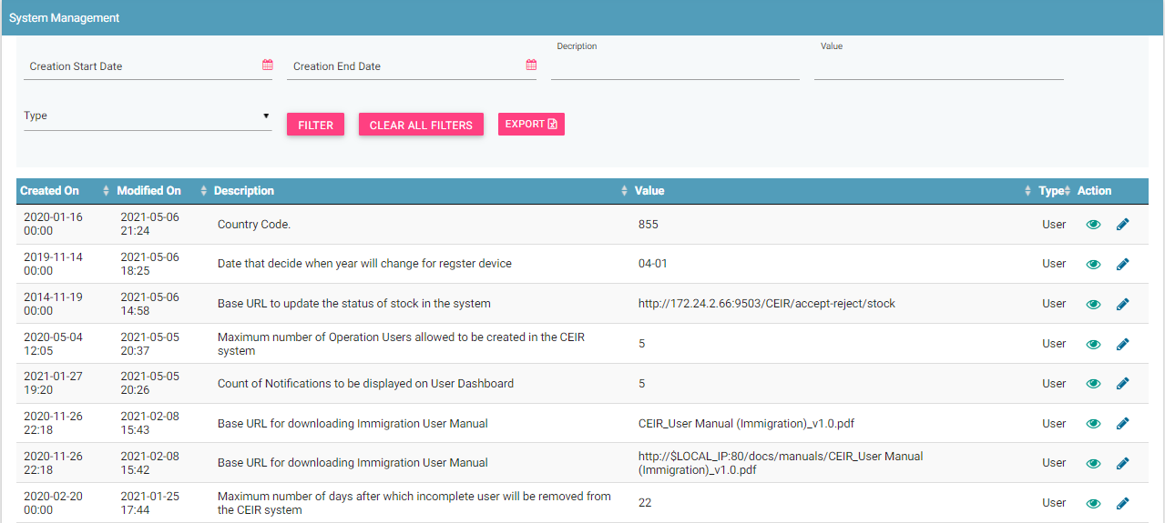

Figure 10: System Management – Filter Option

1. Enter the required value in one or more of the listed fields:

* **Type**: Select the configuration parameter type

1. Click **FILTER**.

The parameter that matches the specified values is shown in the dashboard.

## Message Management

Using this feature, System admin can configure the Email/SMS notification/message to be sent to the users. There are two types of channels using which message can be delivered:

* SMS
* Email

Message parameter can be changed by system admin. The parameter would come into effect from the next time the new requests are processed.

To configure message parameters:

1. Select **Message Management** in the left panel.

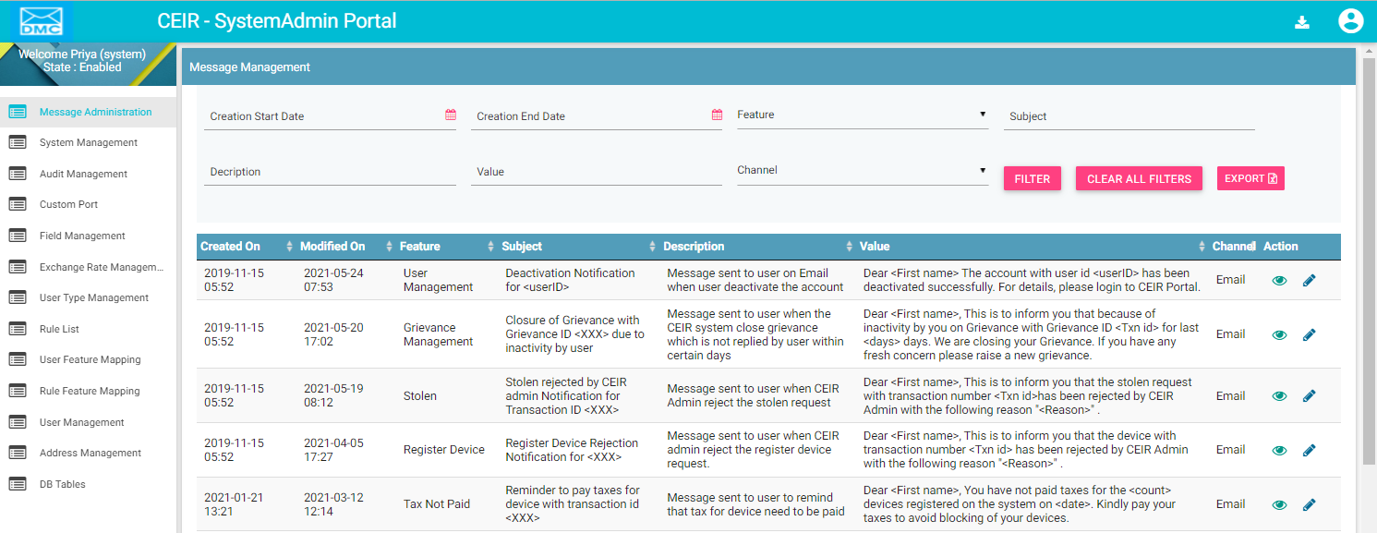

Figure 11: System Management – View All

The following columns are seen in the Message Management Page

| **Column** | **Description** |
| --- | --- |
| Created On | This is the date of installation of system. |
| Modified On | Date when message is last modified. |
| Feature | Which feature the message belongs to. |
| Subject | Subject of the message. |
| Description | Description of the message. |
| Value | Current Value assigned to the message. |
| Channel | Whether the channel is of SMS or E-mail |
| Action | This displays different actions that can be performed on the message.   * View : This is used to view the message details. * Edit A close up of a logo    Description automatically generated: This is used to modify the message details. |

Refer to Annex 2 for complete list of messages.

## Edit Message

System Admins can modify the parameter of type user.

To edit parameter:

1. Click **Edit (A close up of a logo

   Description automatically generated)** against the message entry to be modified.
2. The **Edit Message Management** page appears.

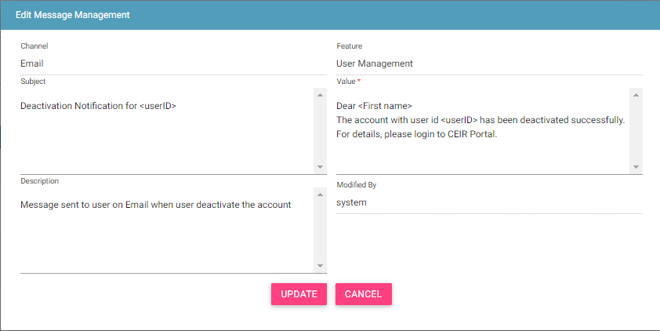

Figure 12: Message Management - Edit

1. Make the required changes.
2. Click **UPDATE**.

## Filter Message

System Admins can view selective message by defining specific values in the listed fields. For example, System Admins can view the entire message sent on channel as email.

To view specific parameter:

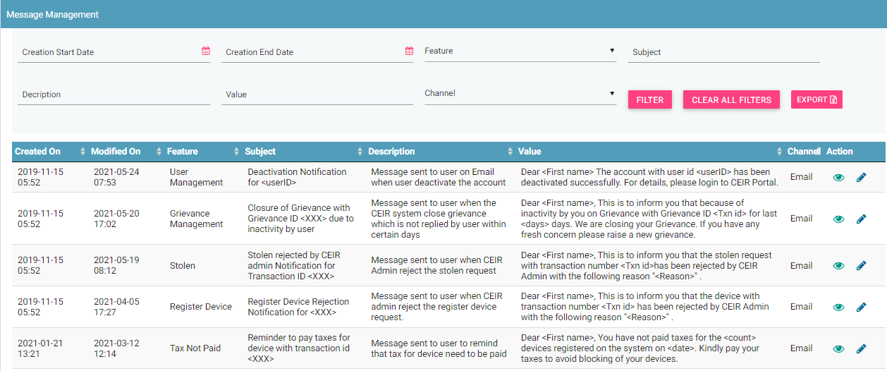

Figure 13: Message Management – Filter Option

1. Enter the required value in one or more of the listed fields:

* **Type**: Select the configuration parameter type

1. Click **FILTER**.

The parameter that matches the specified values is shown in the dashboard.

## Custom Port

System Admins can configure the custom port information using this feature.

To configure custom port related parameters:

1. Select **Custom Port** in the left panel.

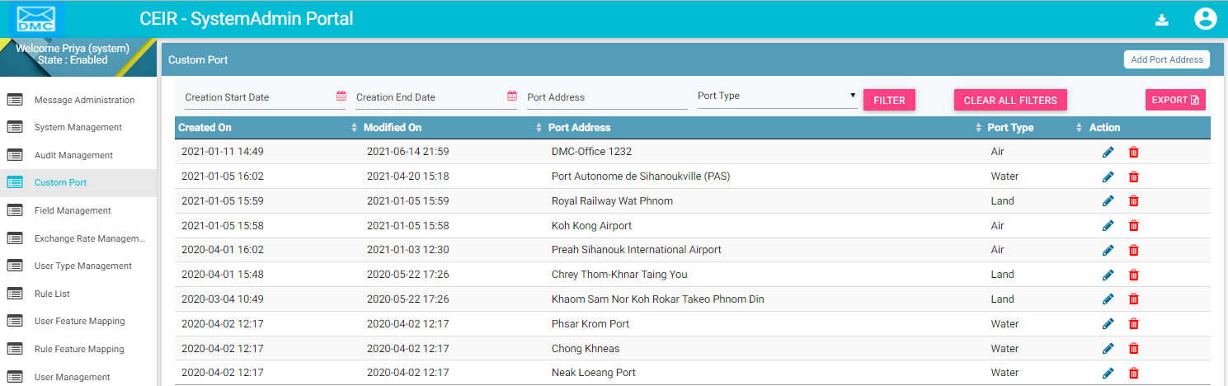

Figure 14: Custom Port – View All

The following columns are seen in the Custom Port Page

| **Column** | **Description** |
| --- | --- |
| Created On | This is the date of installation of system. |
| Modified On | Date when message is last modified. |
| Port Type | Port Type: Water, Land and Air |
| Port Address | The address of the port. |
| Action | This displays different actions that can be performed on the port parameter.   * View : This is used to view the parameter details. * Edit A close up of a logo    Description automatically generated: This is used to modify the parameter details. |

## Edit Port Parameters

System Admins can modify the port related parameter.

To edit parameter:

1. Click **Edit (A close up of a logo

   Description automatically generated)** against the message entry to be modified.
2. The **Edit Custom Port** page appears.

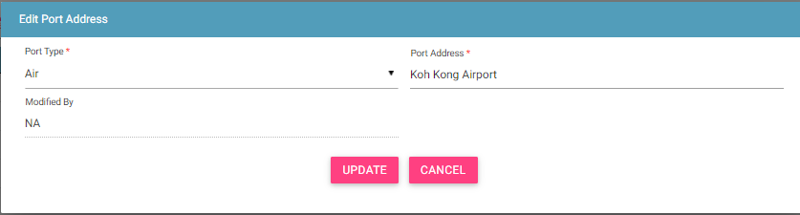

Figure 15: Custom Port - Edit

1. Make the required changes.
2. Click **UPDATE**.

## Filter Custom Port

System Admins can view selective information by defining specific values in the listed fields. For example, System Admins can view the entire address for port type as Water.

To view specific parameter:

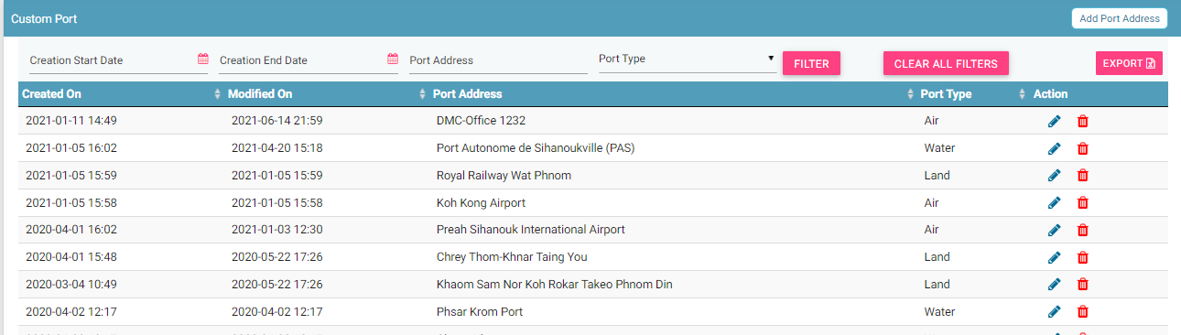

Figure 16: Custom Port – Filter Option

1. Enter the required value in one or more of the listed fields:

* **Port Type**: Select the port type

1. Click **FILTER**.

The parameter that matches the specified values is shown in the dashboard.

## Field Management

System Admins can configure the value of various fields in the CEIR system. The fields are the following types:

1. File Fields in the input file as uploaded by stakeholder. For example, importer uploads a file while registering the consignment. The file contains various fields like device type.
2. Form Field that is shown in the form as displayed to the user. For example, the custom registration form has drop down to list down all the port types like water, land and air.
3. Status Field that is shown in the various filters in the form. For example, there is various status of the consignment like NEW, PROCESSING etc. The system contains a state logic based on these field values.
4. System Fields that are shown in the various views in form of tables field values. For example, the alert can be raised or cleared. The value for same is displayed

To configure field parameters:

1. Select **Field Management** in the left panel.

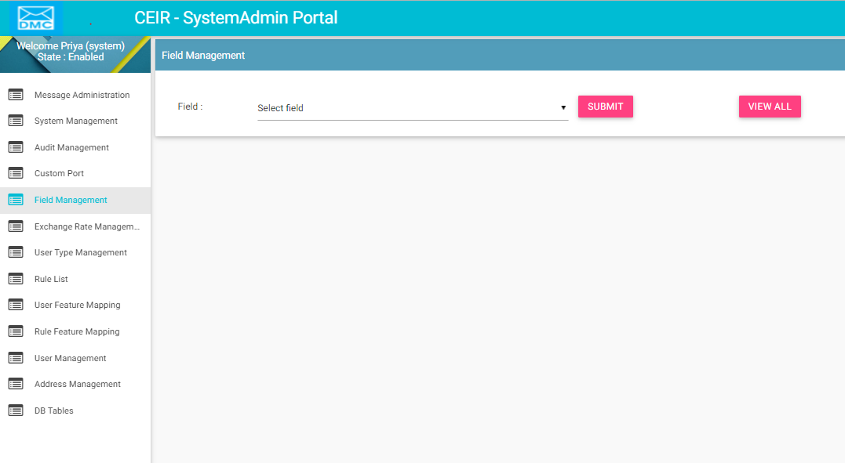

Figure 17: Field Management

The following columns are seen in the Field Management Page once a form field is selected:

| **Column** | **Description** |
| --- | --- |
| Created On | This is the date of installation of system. |
| Modified On | Date when field is last modified. |
| Field | The tag assigned to the field. |
| Display Name | The name that will be displayed on the form |
| Field ID | This is used in special scenarios |
| Description | Description of the field name |
| Action | This displays different actions that can be performed on the field parameter.   * View : This is used to view the field parameter details. * Edit A close up of a logo    Description automatically generated: This is used to modify the field parameter details. |

Field ID is used in special cases. For example, in case of document type, if any document like VAT is uploaded, then the same should be maintained in a separate folder.

View All parameters:

User has the option to view all the parameters together. Click on **View All** on field management home page. User can view all parameters described in the CEIR portal.

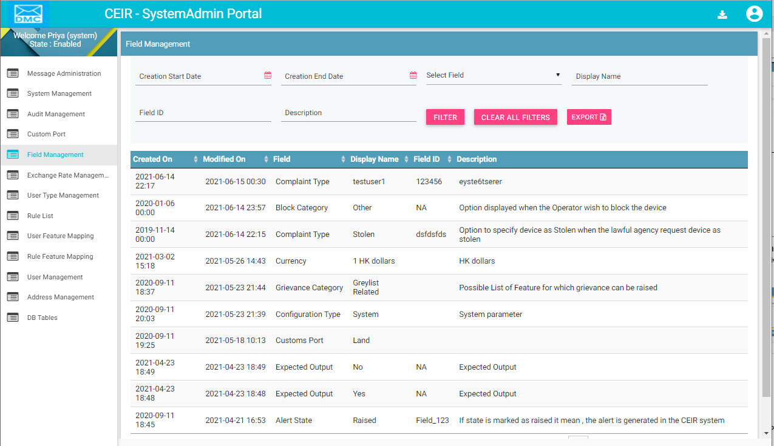

Figure 18: Field Management – View All

## Edit Field Parameters

System Admins can modify the field related parameter.

To edit parameter:

1. Click **Edit (A close up of a logo

   Description automatically generated)** against the field parameter entry to be modified.
2. The **Edit Field Management** page appears.

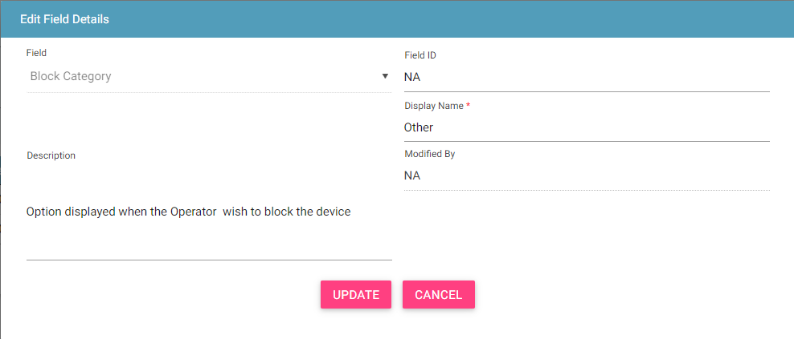

Figure 19: Field Management - Edit

1. Make the required changes.
2. Click **UPDATE**.

## Filter Field Management

System Admins can view selective information by defining specific values in the listed fields. For example, System Admins can view the entire parameter list for a given field type

To view specific parameter:

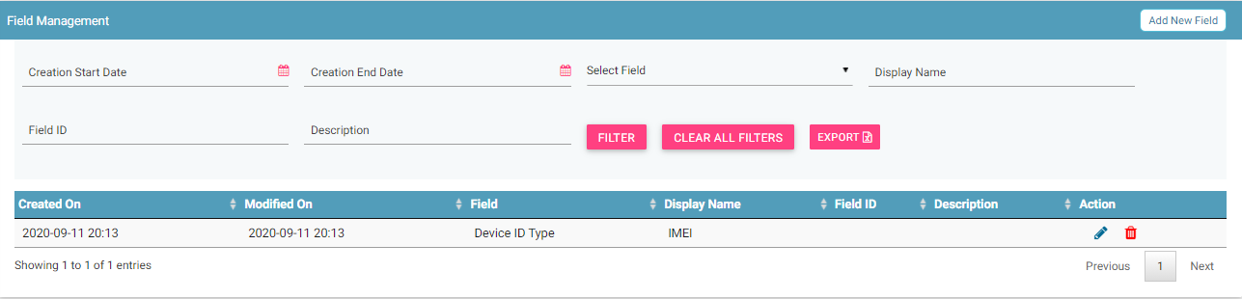

Figure 20: Field Management – Filter Option

1. Enter the required value in one or more of the listed fields:

* **Field**: Select Field

1. Click **FILTER**.

The parameter that matches the specified values is shown in the dashboard.

## Add new field in Field Management

System Admins can add a new value to existing field in the CEIR system. For example, System Admins can add a new field value in existing field say “block category”. Once the value is added, then the same is displayed in the drop-down option when the operator block the IMEI.

To add new value to specific field:



Figure 21: Field Management – Add new field

1. Select the field
2. Once field value is displayed, Select the Add New Field option
3. Enter the required value

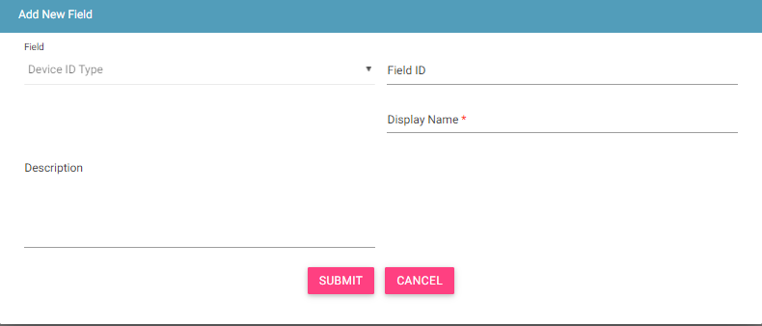

Figure 22: Field Management – Add Value Option

The following columns are seen in the Field Management Page once a form to add a new value is selected:

| **Column** | **Description** |
| --- | --- |
| Created On | Date of creation |
| Modified On | Date of last modification |
| Field | Field for which new value is to be added. |
| Description | The description of the value |
| Display Name | The value to be shown. |
| Field ID | To be used in special scenarios. |

Click **Submit**. The new parameter is saved.

## Exchange Rate Management

System Admins can configure the Exchange Rate on monthly basis for all supported currency in the CEIR system.

To configure Exchange Rate parameters:

1. Select **Exchange Rate Management** in the left panel.

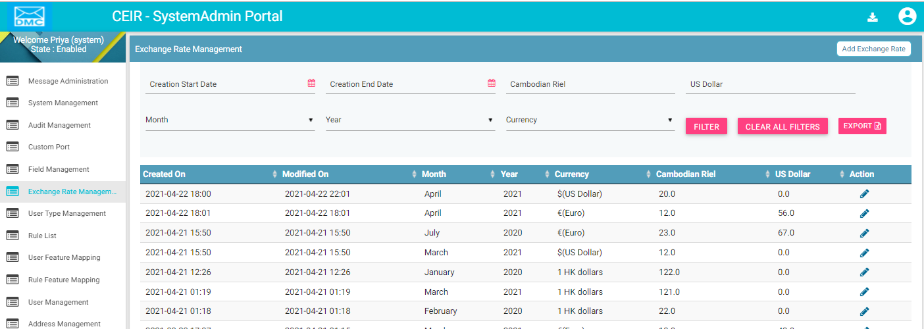

Figure 23: Exchange Rate Management – View All

The following columns are seen in the Field Management Page once a form field is selected:

| **Column** | **Description** |
| --- | --- |
| Created On | This is the date of installation of system. |
| Modified On | Date when field is last modified. |
| Month | The month for which the conversion rate is valid. |
| Currency | Currency for which the conversion rate is provided. |
| Year | Year for which the conversion date is provided. |
| Cambodian Riel | The conversion rate in Cambodian Riel. |
| US Dollar | The conversion rate in US Dollar. |
| Action | This displays different actions that can be performed on the currency parameter.   * Edit A close up of a logo    Description automatically generated: This is used to modify the field parameter details. |

For example, if the currency is Euro, then the conversion rate is mentioned as follows

Value in Cambodian Riel is 4535.52 as 1 Euro is equal to 4535.52 Cambodian Riel

Value in Dollar is 1.12 as 1 Euro is equal to 1.12 US Dollar.

## Edit Exchange Rate Parameters

System Admins can modify the Exchange Rate related parameter.

To edit parameter:

1. Click **Edit (A close up of a logo

   Description automatically generated)** against the field parameter entry to be modified.
2. The **Edit Field Management** page appears.

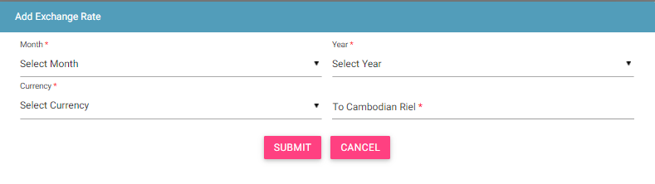

Figure 24: Currency Management - Edit

1. Make the required changes.
2. Click **UPDATE**.

## Filter Currency Management

System Admins can view selective information by defining specific values in the listed fields. For example, System Admins can view the entire parameter list for a given field type

To view specific parameter:

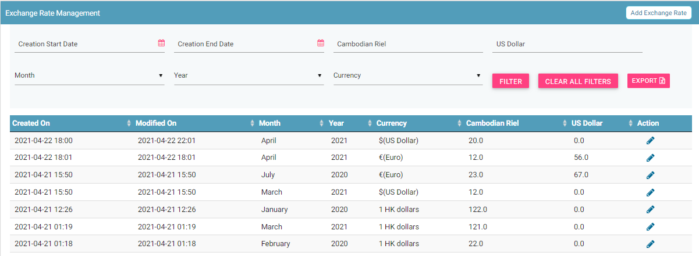

Figure 25: Field Management – Filter Option

1. Enter the required value in one or more of the listed fields:

* **Start Date**: Select Start Date
* **End Date**: Select End Date
* **Cambodian Riel**: Value in Cambodian Riel
* **US Dollar**: Value in US Dollar
* **Month**: Select Month
* **Year:** Select year
* **Currency**: Drop containing the currency list.

1. Click **FILTER**.

The parameter that matches the specified values is shown in the dashboard.

## Add Currency Management

System Admins can add a new conversion rate for a month for all the supported currency in the CEIR system.

To add new conversion rate to given currency:



Figure 26: Field Management – Filter Option

1. Select the Add Currency option
2. Enter the required value

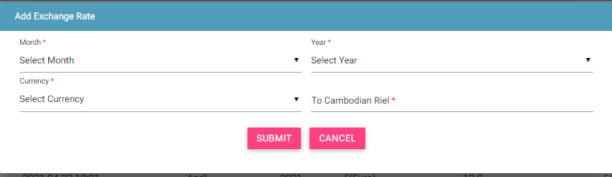

Figure 27: Currency Management – Add Option

The following columns are seen in the Add Currency Page once a form is selected:

| **Column** | **Description** |
| --- | --- |
| Month | The month for which the conversion rate is valid. |
| Currency | Currency for which the conversion rate is provided. |
| Year | Year for which conversion rate is valid. |
| Cambodian Riel | The conversion rate in Cambodian Riel. |
| Dollar | The conversion rate in US Dollar. |

1. Click **Submit**.

The conversion rate for currency is saved.

## Audit Management

System Admins can view all the user related activity via this feature

To view user activity:

1. Select **Audit Management** in the left panel.

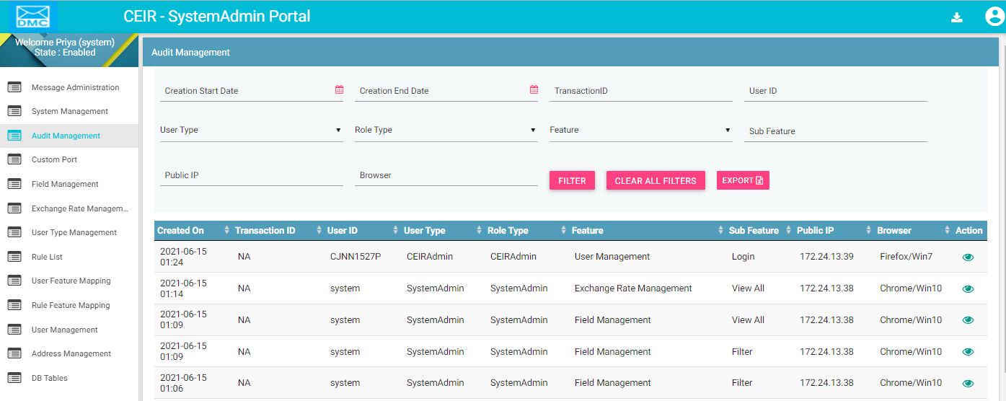

Figure 28: Audit Management – View All

The following columns are seen in the Audit Management Page once a form field is selected:

| **Column** | **Description** |
| --- | --- |
| Created On | The date when the activity is performed. |
| Transaction ID | Transaction ID if any related to that activity. It can also include user name in case of user management related activity |
| User ID | User name of the Stakeholder. |
| User Type | User Type like Importer |
| Role Type | Role type like Importer/Retailer/Distributor |
| Feature | Name of the feature on which the activity is performed. |
| Sub Feature | The conversion rate in US Dollar. |
| Public IP | IP of the user machine. |
| Browser | User’s browser details. |
| Action | This displays different actions that can be performed on the activity.   * View : This is used to view the activity details. |

## Filter Audit Management

System Admins can view selective information by defining specific values in the listed fields. For example, System Admins can view the entire parameter list for a given field type

To view specific parameter:



Figure 29: Audit Management – Filter Option

1. Enter the required value in one or more of the listed fields:

* **Start Date**: Select Start Date
* **End Date**: Select End Date
* **Transaction ID**: Enter Transaction ID
* **User ID**: Enter User ID
* **User Type**: Select the user type from dropdown.
* **Role Type**: Select Role type from dropdown.
* **Feature**: Select Feature Name
* **Sub Feature:** Select Sub Feature Name
* **Public IP:** Enter public ip
* **Browser:** Enter browser

1. Click **FILTER**.

The parameter that matches the specified values is shown.

## User Type Management

System Admins can enable/disable user type available in the CEIR system. User type denote category of user. There can be two types of users:

* Internal User
* External User

External users are registered through the portal by self-registration method whereas Internal users are registered by System Admin.

To view user types:

1. Select **User Type Management** in the left panel.

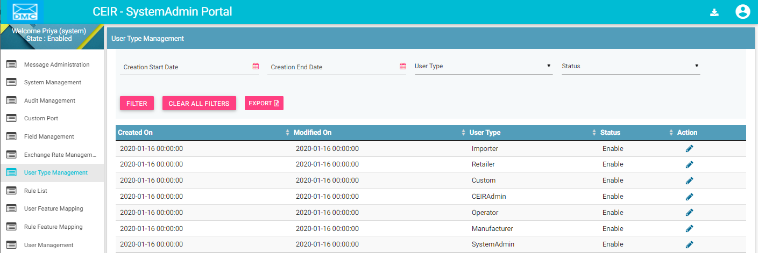

Figure 30: Policy Management – View All

The following columns are seen in the Field Management Page once a form field is selected:

| **Column** | **Description** |
| --- | --- |
| Created On | This is the date of installation of system. |
| Modified On | Date when field is last modified. |
| User Type | The description of the user type. |
| Status | Whether this user type is enabled or not in the system. |
| Action | This displays different actions that can be performed on the currency parameter.   * Edit A close up of a logo    Description automatically generated: This is used to modify the policy parameter details. |

## Edit User type

System Admins can enable/disable the user type.

To edit user type:

1. Click **Edit (A close up of a logo

   Description automatically generated)** against the user type entry to be modified.
2. The **Change user type status** page appears.

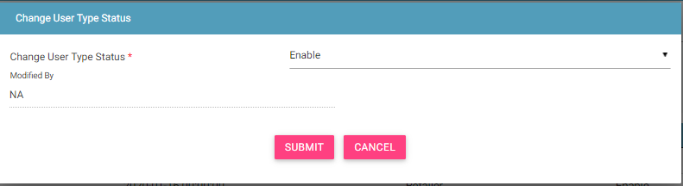

Figure 31: User Type Management - Edit

1. Make the required changes.
2. Click **UPDATE**.

## Filter User Type Management

System Admins can view selective information by defining specific values in the listed fields. For example, System Admins can view the entire user list for a type as enabled.

To view specific parameter:

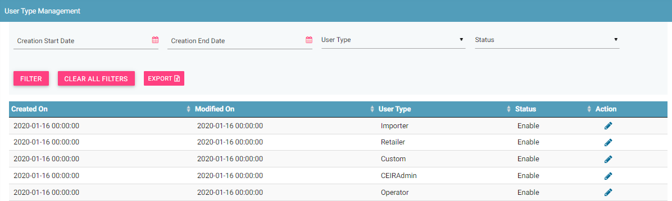

Figure 32: User Type Management – Filter Option

1. Enter the required value in one or more of the listed fields:

* **Creation start and end date**: Select start and end date
* **User Type:** Select Type
* **Status**: Select Status

1. Click **FILTER**.

The parameter that matches the specified values is shown in the dashboard.

## Rule List

System Admins can view all the rules defined in the system. Rules will be applied when the user requests like upload stock, register consignments, stolen/recovery requests are processed by the system processes.

To view rules applied:

1. Select **Rule list** in the left panel.

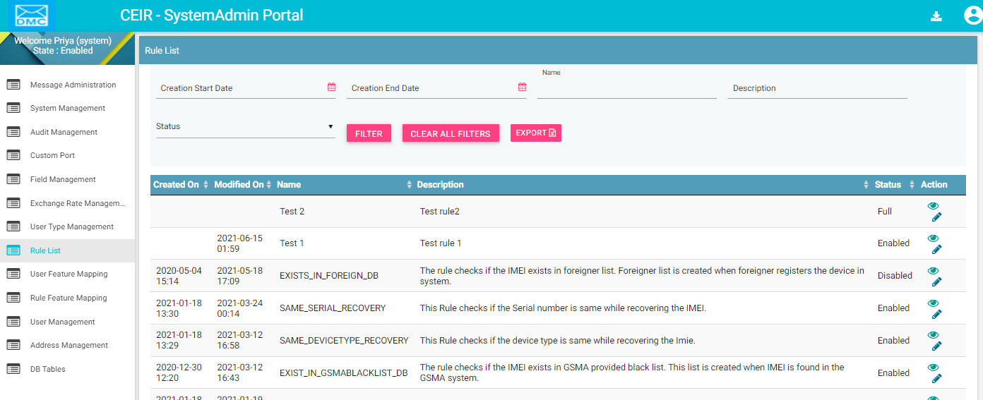

Figure 33: Rule List – View All

The following columns are seen in the Rule List Page once a form field is selected:

| **Column** | **Description** |
| --- | --- |
| Created On | This is the date of installation of system. |
| Modified On | Date when field is last modified. |
| Name | Name of the rule |
| Description | The description of the rule. |
| Status | Whether this parameter is enabled or not in the system. |
| Action | This displays different actions that can be performed on the currency parameter.   * Edit A close up of a logo    Description automatically generated: This is used to modify the policy parameter details. * View : This is used to view the policy parameter details. |

## Edit Rule List

System Admins can modify the rule list parameter.

To edit parameter:

1. Click **Edit (A close up of a logo

   Description automatically generated)** against the rule list entry to be modified.
2. The **Edit Rule list** page appears.

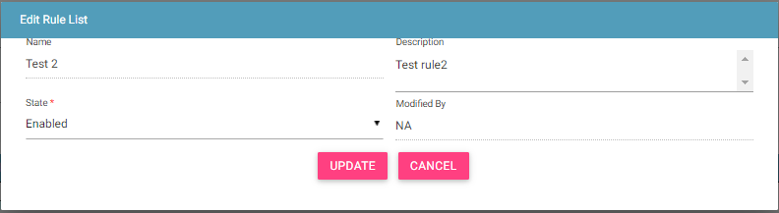

Figure 34: Rule List- Edit

1. Make the required changes.
2. Click **UPDATE**.

## Filter Rule list

System Admins can view selective information by defining specific values in the listed fields. For example, System Admins can view the entire rules list for a type as enabled.

To view specific rule:



Figure 35: Rule List – Filter Option

1. Enter the required value in one or more of the listed fields:

* **Start and end dates**: Select dates
* **Name** : Select Name
* **Description** : Select Description
* **Status**: Select Status

1. Click **FILTER**.

The rules that match the specified values is shown in the dashboard.

## User Feature Mapping

System Admins can configure the user feature mapping in the CEIR system.

To configure user feature mapping:

1. Select **User Feature Mapping** in the left panel.

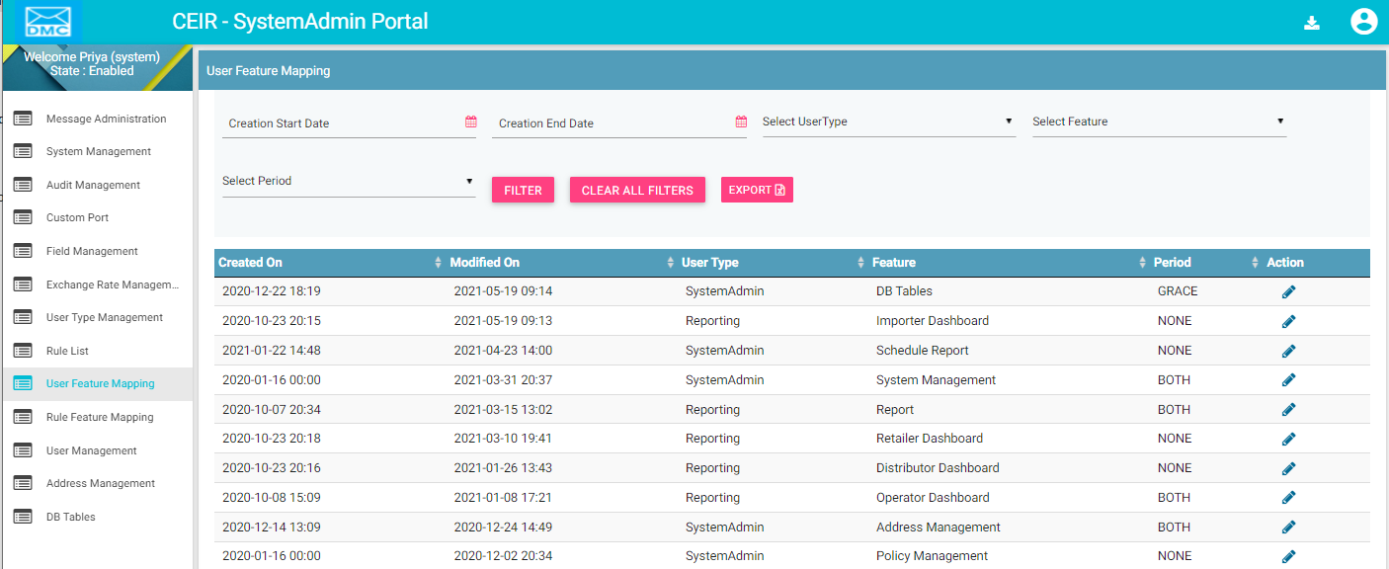

Figure 36: User Feature Mapping – View All

The following columns are seen in the user feature mapping Page once a form field is selected:

| **Column** | **Description** |
| --- | --- |
| Created On | This is the date of installation of system. |
| Modified On | Date when field is last modified. |
| User Type | The description of the user type. |
| Feature | Feature which is to be enabled/disabled for the user type |
| Period | CEIR period for which this parameter is applicable The value can be grace, post-grace or both. |
| Action | This displays different actions that can be performed on the currency parameter.   * Edit A close up of a logo    Description automatically generated: This is used to modify the policy parameter details. |

## Edit user feature mapping

System Admins can modify the user feature mapping.

To edit parameter:

1. Click **Edit (A close up of a logo

   Description automatically generated)** against the policy parameter entry to be modified.
2. The **Edit User Feature Mapping** page appears.

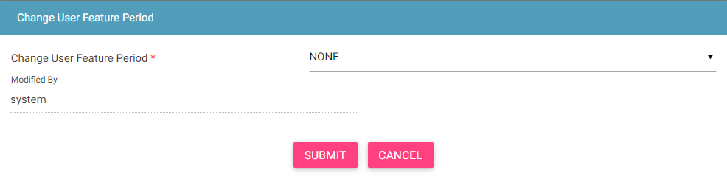

Figure 37: User Feature Mapping - Edit

1. Make the required changes.
2. Click **UPDATE**.

## Filter User Feature Mapping

System Admins can view selective information by defining specific values in the listed fields. For example, System Admins can view the entire parameter list for a type as enabled.

To view specific user feature mapping:

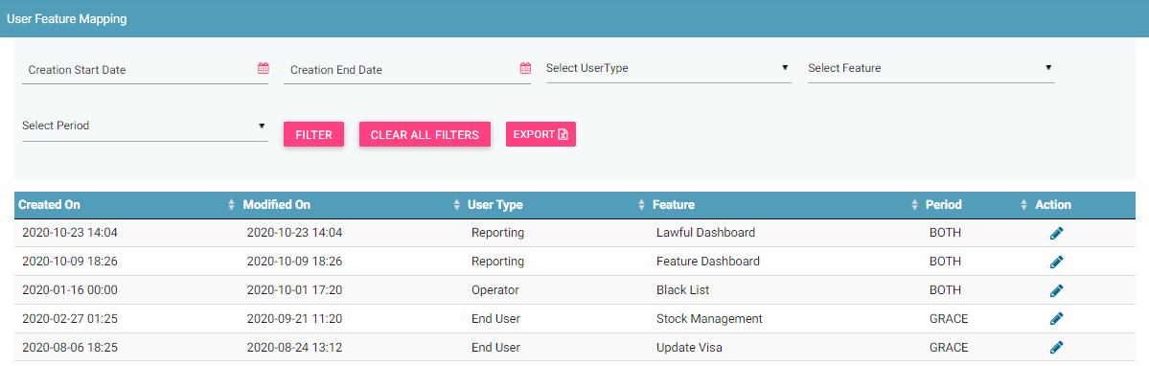

Figure 38: User Feature Mapping – Filter Option

1. Enter the required value in one or more of the listed fields:

* **Date:** Select date
* **User Type**: Select Type
* **Feature:** Select feature
* **Period:** Select Period

1. Click **FILTER**.

The user types that match the specified values are shown in the dashboard.

## Rule Feature Mapping

System Admins can configure rule feature mapping in the CEIR system.

To configure rule feature mapping:

1. Select **Rule Feature Mapping** in the left panel.

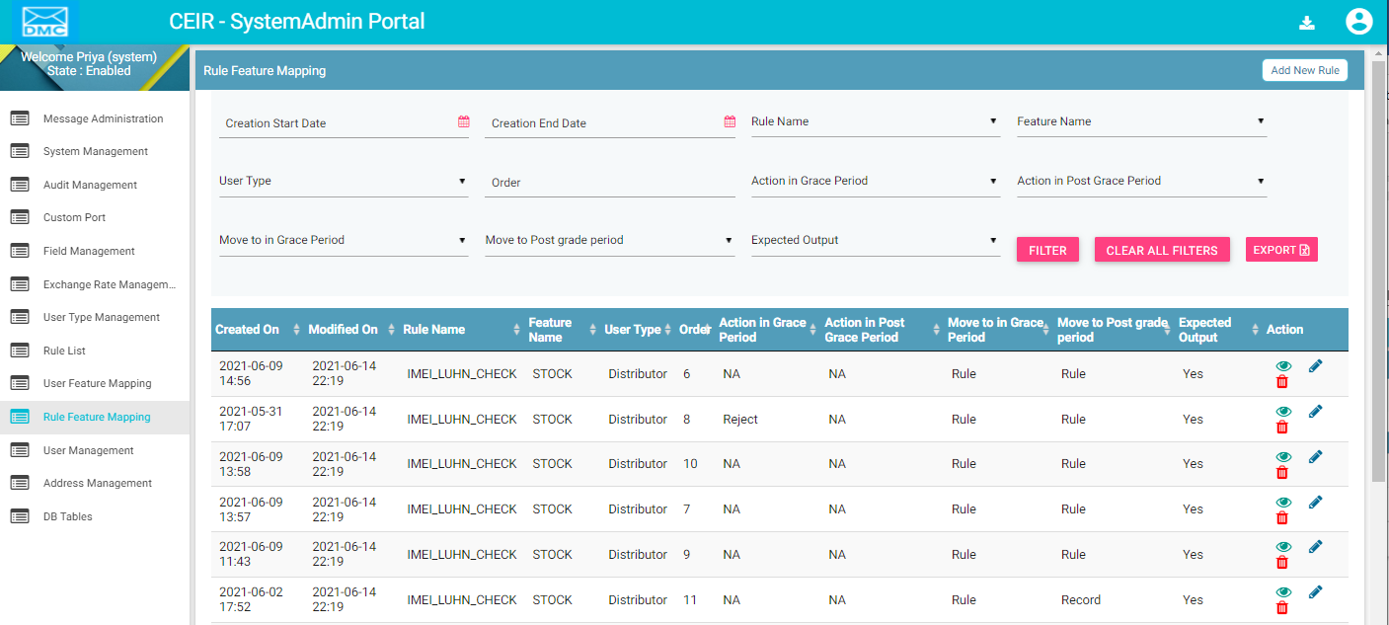

Figure 39: Rule Feature Mapping – View All

The following columns are seen in the Rule Feature Mapping Page once a form field is selected:

| **Column** | **Description** |
| --- | --- |
| Created On | This is the date of installation of system. |
| Modified On | Date when field is last modified. |
| Rule Name | The Rule Name. |
| Feature Name | Feature name |
| User Type | Select User Type for which this rule will be applicable |
| Order | Order in which this rule will be executed |
| Action in Grace Period | Whether action is to be taken in grace period or not |
| Action in Port Grace Period | Whether action is to be taken in post grace period |
| Move to in Grace period | Moved to in grace period |
| Move to Post Grace Period | Move to post grace period |
| Expected Output | Expected output for the rule |
| Action | This displays different actions that can be performed on the currency parameter.   * Edit A close up of a logo    Description automatically generated: This is used to modify the user feature mapping. * View : This is used to view the user feature mapping. * Delete : This is used to delete the rule feature mapping. |

## Edit Rule Feature Mapping

System Admins can modify the rule feature mapping.

To edit parameter:

1. Click **Edit (A close up of a logo

   Description automatically generated)** against the rule feature entry to be modified.
2. The **Edit Rule Feature Mapping** page appears.

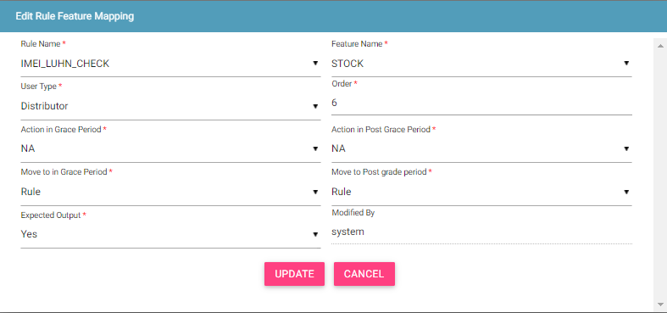

Figure 40: Rule Feature Mapping - Edit

1. Make the required changes.
2. Click **UPDATE**.

## Filter Rule Feature Mapping

System Admins can view selective information by defining specific values in the listed fields. For example, System Admins can view the entire rule feature mapping for a type as enabled.

To view specific rule feature mapping:

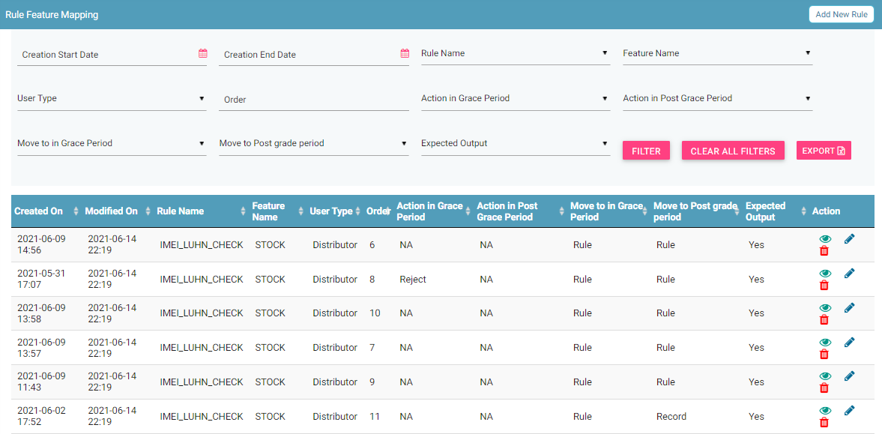

Figure 41: Rule Feature Mapping – Filter Option

1. Enter the required value in one or more of the listed fields:

* **Rule Name:** Name of the rule
* **Feature Name:** Feature name
* **User Type:** This rule will be applicable to which user type
* **Order:** Order in which this rule will be executed
* **Action in Grace Period:** Action that will be performed in Grace period on this rule.
* **Action in Post Grace Period:** Action that will be performed in Post Grace period on this rule.
* **Move to in Grace Period:** Move to in Grace Period
* **Move to Post Grace Period:** Move to post grace period
* **Expected Output:** Expected output

1. Click **FILTER**.

The parameter that matches the specified values is shown in the dashboard.

## User Management

System Admins can configure the internal users in the CEIR system.

To configure Users:

1. Select **User Management** in the left panel.

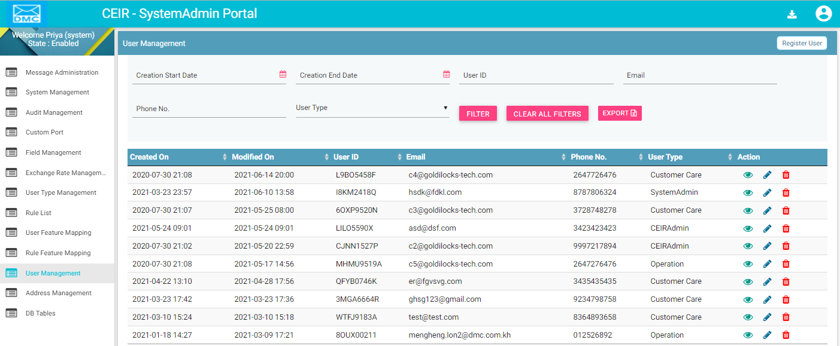

Figure 42: User Management – View All

The following columns are seen in the User Management Page once a form field is selected:

| **Column** | **Description** |
| --- | --- |
| Created On | This is the date of installation of system. |
| Modified On | Date when field is last modified. |
| User ID | User ID |
| Email | Email ID of the user |
| Phone No | Phone number of the user |
| User Type | User Type |
| Action | This displays different actions that can be performed on the user.   * Edit A close up of a logo    Description automatically generated: This is used to modify the user details. * View : This is used to view the user details. * Delete : This is used to delete the user permanently. |

## Edit Users information

System Admins can modify the user information.

To edit user information:

1. Click **Edit (A close up of a logo

   Description automatically generated)** against the user entry to be modified.
2. The **Edit User** page appears.

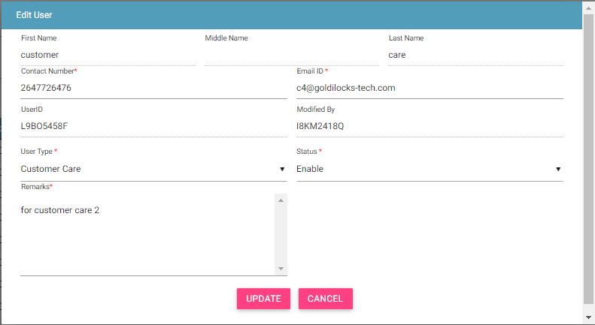

Figure 43: User Management - Edit

1. Make the required changes.
2. Click **UPDATE**.

## Filter Users

System Admins can view selective information by defining specific values in the listed fields. For example, System Admins can view specific user detail.

To view specific user details:

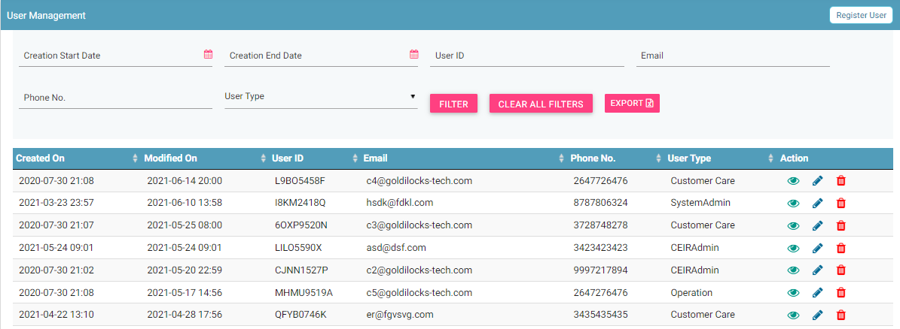

Figure 44: User Management – Filter Option

1. Enter the required value in one or more of the listed fields:

* **Date** : Select date
* User ID: user ID which is system generated
* Email: Email ID of the user
* Phone No.: Contact number of the user
* User Type: Type of the user

1. Click **FILTER**.

The user details that match the specified values are shown in the dashboard.

## Address Management

System Admins can configure the address in the CEIR system.

To configure addresses:

1. Select **Address Management** in the left panel.

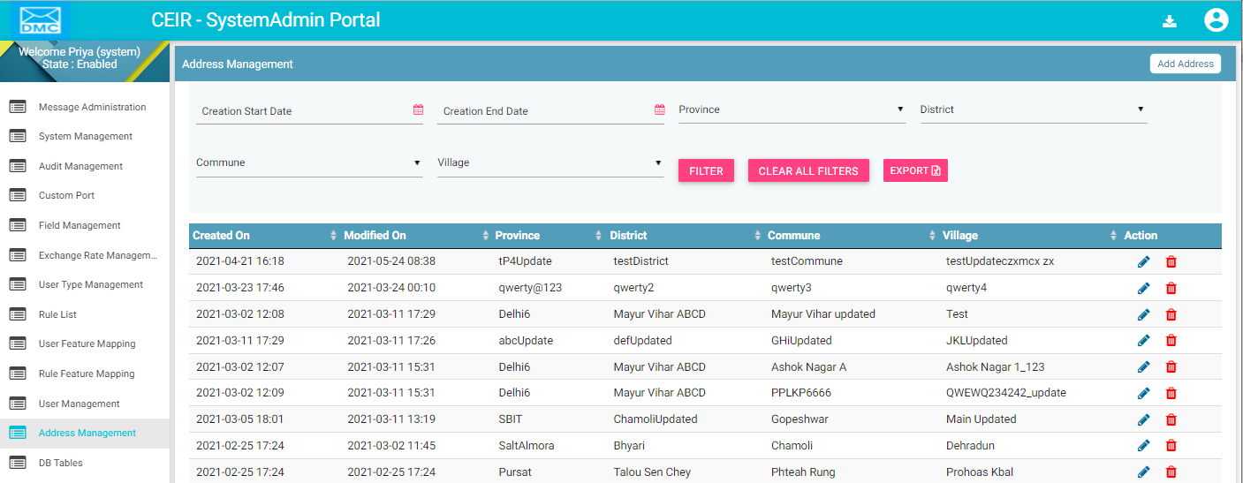

Figure 45: Address Management – View All

The following columns are seen in the Address Management Page once a form field is selected:

| **Column** | **Description** |
| --- | --- |
| Created On | This is the date of installation of system. |
| Modified On | Date when field is last modified. |
| Province | Province details |
| District | District details |
| Commune | Commune details |
| Village | Village details |
| Action | This displays different actions that can be performed on the address details.   * Edit A close up of a logo    Description automatically generated: This is used to modify the address details. * Delete : This is used to delete the address details. |

## Edit Address details

System Admins can modify the Address details.

To edit parameter:

1. Click **Edit (A close up of a logo

   Description automatically generated)** against the address details to be modified.
2. The **Edit Address Management** page appears.

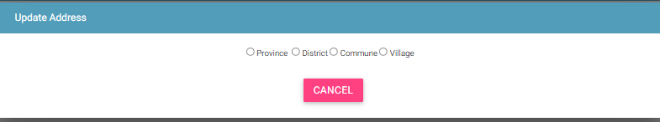

Figure 46: Address Management - Edit

1. Make the required changes.
2. Click **UPDATE**.

## Filter Address Management

System Admins can view selective information by defining specific values in the listed fields. For example, System Admins can view the address details based on a specific parameter value.

To view specific address details:

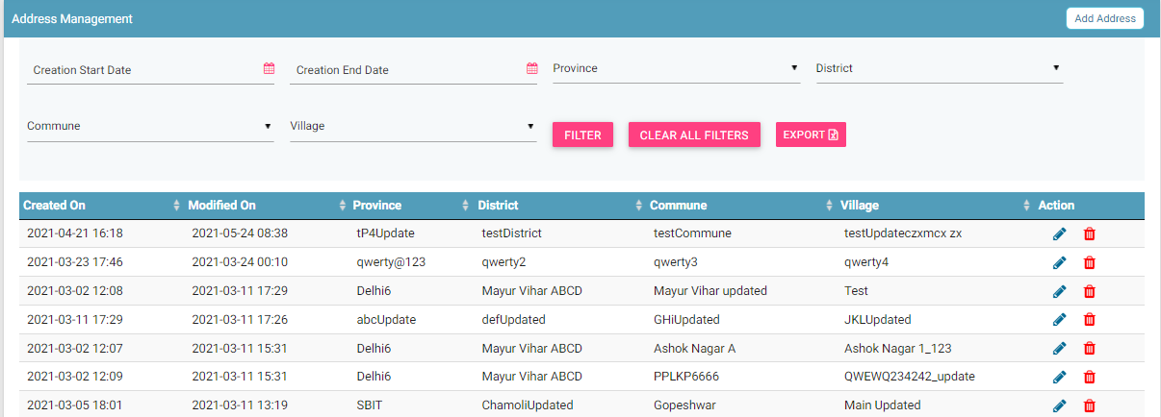

Figure 47: Address Management – Filter Option

1. Enter the required value in one or more of the listed fields:

* **Province:** Province
* **District:** District
* **Commune:** Commune
* **Village:** Village

1. Click **FILTER**.

The parameter that matches the specified values is shown in the dashboard.

## DB Tables

DB Tables feature is a troubleshooting tool to view and verify the parameter values in database tables. Also have the facility to export the tables.

System Admins can view the database tables using this feature.

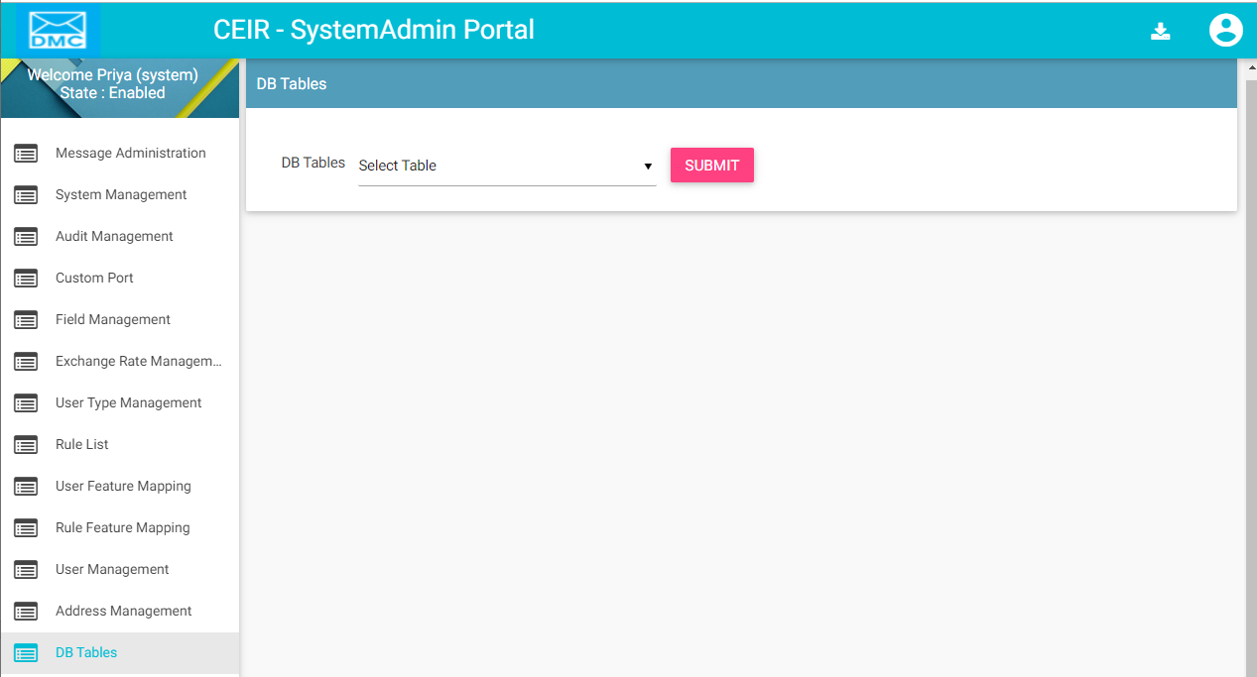

Figure 48: DB Tables

Data in tables can be sorted based on dates.

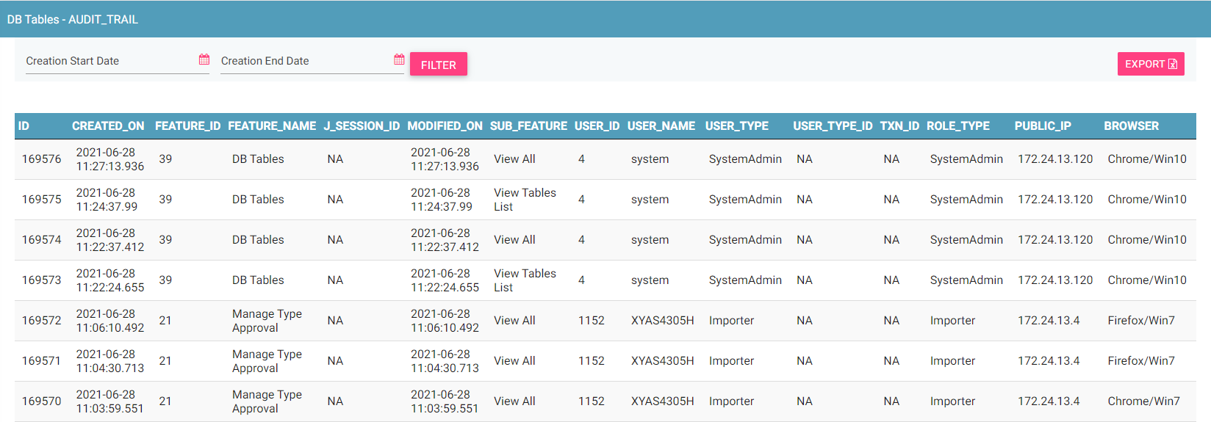

Figure 49: DB Tables – view specific table

The table data can be exported using the Export button on the top right.

## Annex 1

This section describes the list of parameters.

The list is categorized based on the different functionality in the system

Register Device Feature Related Parameters

| **Parameter Name** | **Possible Value** |
| --- | --- |
| Date in MM-DD format that decide when the year start for Cambodian user. If value is 04-01, it means that the year is from 1 April to 31st March. | 04-01 |
| Time Period in days given to end user to pay custom tax and regularize the device | 30 |
| Visa Expiry Period in days in case visa details are not provided by foreigner while registering the device | 30 |
| Flag to indicate if the Notification is to be sent for Tax not Paid case to end user. | Y. Y stands for Yes and N stand for No |

Blacklist Feature Related Parameters

| **Parameter Name** | **Possible Value** |
| --- | --- |
| Base Path from where full and incremental blacklist file would be maintained in the CEIR system | /var/www/html/downloads/blackListFiles/ |
| Time Period in days when the Full Blacklist file would be generated in the CEIR system. | 7 |
| Time Period in days when the Incremental Blacklist file would be generated in the CEIR system | 1 |
| Base URL from where full and incremental Blacklist file would be available for download by operator from the CEIR system. | http://13.127.239.247/downloads/blackListFiles/ |
| Dirty Period in days for which the blacklist number found in GSMA are maintained in the CEIR system. | 180 |

Greylist Feature Related Parameters

| **Parameter Name** | **Possible Value** |
| --- | --- |
| Base Path from where full and incremental Greylist file would be maintained in the CEIR system | /var/www/html/downloads/greylistFiles/ |
| Time Period in days when the Full Greylist file would be generated in the CEIR system. | 7 |
| Time Period in days when the Incremental Greylist file would be generated in the CEIR system | 1 |
| Base URL from where full and incremental Greylist file would be available for download by operator from the CEIR system. | <http://13.127.239.247/downloads> /greyListFiles/ |
| Time Period in days when the IMEI will move from greylist to blacklist in the CEIR system. | 30 |
| Day of the Week in MMM format on which Greylist or Blacklist will be generated by CEIR system. This parameter is valid only when frequency is weekly (7 days). | Sun |

Operator CDR Feature Related Parameters

| **Parameter Name** | **Possible Value** |
| --- | --- |
| Value of Mobile Country Code (MCC) for Cambodia | 855 |
| Base Path where ETL system uploads the CDR files via FTP in the CEIR system | /home/ubuntu/ETL |
| Maximum Number of one IMEI mapped to different MSISDN to avoid duplicate count | 5 |

Grievance Feature Related Parameters

| **Parameter Name** | **Possible Value** |
| --- | --- |
| Time Period in days given to user to respond to grievance. Post expiry, the grievance is marked as closed by the CEIR system | 10 |
| Maximum number of document that can be uploaded at the time of raising grievance | 3 |

Notification Feature Related Parameters

| **Parameter Name** | **Possible Value** |
| --- | --- |
| Mail Signature to be added at the end of each mail sent from the CEIR system | Regards  CEIR Admin |
| Number of Notifications to be displayed in descending order on Dashboard for all users | 10 |
| Time Period in days before which reminder has to be sent before action is to be taken by CEIR system | 3 |

SLA Feature Related Parameters

| **Parameter Name** | **Possible Value** |
| --- | --- |
| SLA Breach period in days to approve the consignment by CEIR Admin | 3 |
| SLA Breach period in days to reply to grievance by CEIR Admin | 3 |
| SLA Breach period in days to approve the stock uploaded by stakeholder or endusers | 3 |

Stolen/Recovery Feature Related Parameters

| **Parameter Name** | **Possible Value** |
| --- | --- |
| Time Period in days to look in operator CDR in case mobile number is only provided in stolen device case | 10 |

TAC Feature Related Parameters

| **Parameter Name** | **Possible Value** |
| --- | --- |
| API Key to be used in TAC HTTPS API provided by GSMA | ZqXBvdRLYRiAWCO |
| Password to be used in TAC HTTPS API provided by GSMA | LdTcsQYaYuxRabQ |
| Salt String to be used in TAC HTTPS API provided by GSMA | GSMA |
| Organization ID to be used in TAC HTTPS API provided by GSMA | 9101 |
| Secret Key to be used in TAC HTTPS API provided by GSMA | imeaesencryption |
| TAC HTTPS API provided by GSMA | <https://imeidb.gsma.com/services/rest/GetHandSetDetails> |
| Dirty Period in day for which the TAC number not found in GSMA are maintained in the CEIR system. | 30 |

User Management Feature Related Parameters

| **Parameter Name** | **Possible Value** |
| --- | --- |
| Base URL Link of DMC Home Page where the user request would be redirected on Home / New user request | http://13.233.39.58:8080/CEIR/DMC |
| Time period in days post expiry the user password will expire | 180 |
| Base URL for downloading User Manual | http://13.233.39.58:8080/Design/manuals/ |
| Maximum number of registration allowed for all user types in the CEIR system | 500000 |
| Maximum number of registration allowed for user type as Importers in the CEIR system | 1000 |
| Maximum number of registration allowed for user type as Distributors in the CEIR system | 10000 |
| Maximum number of registration allowed for user type as Retailer in the CEIR system. | 100000 |
| Maximum number of registration allowed for user type as Custom in the CEIR system | 100 |
| Maximum number of registration allowed for user type as Operators in the CEIR system | 100 |
| Maximum number of registration allowed for user type as TRC in the CEIR system | 10 |
| Maximum number of registration allowed for user type as Manufacturer in the CEIR system | 100 |
| Maximum number of registration allowed for user type as Lawful Agency in the CEIR system | 100 |
| Maximum Number of device registration allowed for user type as End User in the CEIR system | 10000 |
| Maximum number of registration allowed for user type as Immigration in the CEIR system | 100 |
| Maximum number of registration allowed for user type as Customer Care in the CEIR system | 100 |

## Annex 2

This section describes the list of message that is sent as notification to user either via SMS or Email.

The list is categorized based on the different functionality in the system.

Block Device Feature Related Messages

| **Parameter Name** | **Possible Value** |
| --- | --- |
| Message sent to Operator or CEIR Authority when the CEIR admin has approved the request to block devices | Dear <first name>,  This is to inform you that the your block request with transaction number <txn_name> has been approved by CEIR Authority. |
| Message sent to Operator or CEIR Authority when the CEIR admin has rejected the request to block devices | Dear <First name>,  This is to inform you that the block request with transaction number <txn_name> has been rejected by CEIR Authority. |
| Message sent to CEIR Authority when the system has processed the block request successfully | Dear <First name>,  This is to inform you that the block request with transaction number <txn_name> has been processed by system successfully. |
| Message sent to CEIR Authority when the system has processed the block request successfully | Dear CEIR Authority,  This is to inform you that the block request with transaction number <txn_name> has been processed by system successfully. |

Stolen Device Feature Related Messages

| **Parameter Name** | **Possible Value** |
| --- | --- |
| Message sent to Lawful Agency when the CEIR admin has approved the request for stolen devices | Dear <first name>,  This is to inform you that the your Stolen request with transaction number <txn_name> has been approved by CEIR Authority. |
| Message sent to Lawful Agency when the CEIR admin has rejected the request for stolen devices | Dear <First name>,  This is to inform you that the stolen request with transaction number <txn_name> has been rejected by CEIR Authority. |
| Message sent to Lawful Agency when the system has processed the stolen request successfully | Dear <First name>,  This is to inform you that the stolen request with transaction number <txn_name> has been processed by system successfully. |
| Message sent to CEIR Authority when the system has processed the stolen request successfully | Dear CEIR Authority,  This is to inform you that the stolen request with transaction number <txn_name> has been processed by system successfully. |

Unblock Device Feature Related Messages

| **Parameter Name** | **Possible Value** |
| --- | --- |
| Message sent to Operator or CEIR Authority when the CEIR admin has approved the request to unblock devices | Dear <first name>,  This is to inform you that your Unblock request with transaction number <txn_name> has been approved by CEIR Authority. |
| Message sent to Operator or CEIR Authority when the CEIR admin has rejected the request to unblock devices | Dear <First name>,  This is to inform you that your Unblock request with transaction number <txn_name> has been rejected by CEIR Authority. |
| Message sent to Operator or CEIR Authority when the system has processed the unblock request successfully | Dear <First name>,  This is to inform you that the unblock request with transaction number <txn_name> has been processed by system successfully. |
| Message sent to CEIR Authority when the system has processed the unblock request successfully | Dear CEIR Authority,  This is to inform you that the unblock request with transaction number <txn_name> has been processed by system successfully. |

Recovery Device Feature Related Messages

| **Parameter Name** | **Possible Value** |
| --- | --- |
| Message sent to Lawful Agency when the CEIR admin has approved the request for recovered devices | Dear <first name>,  This is to inform you that the your recovery request with transaction number <txn_name> has been approved by CEIR Authority. |
| Message sent to Lawful Agency when the CEIR admin has rejected the request for recovered devices | Dear <First name>,  This is to inform you that the recovery request with transaction number <txn_name> has been rejected by CEIR Authority. |
| Message sent to Lawful Agency when the system has processed the recovered request successfully | Dear <First name>,  This is to inform you that the recovery request with transaction number <txn_name> has been processed by system successfully. |
| Message sent to CEIR Authority when the system has processed the recovered request successfully | Dear CEIR Authority,  This is to inform you that the recovery request with transaction number <txn_name> has been processed by system successfully. |

Consignment Feature Related Messages

| **Parameter Name** | **Possible Value** |
| --- | --- |
| Message sent to Importer when system has rejected the consignment due to processing errors | Dear <user name>,  This is to inform you that the consignment with transaction ID: <txn_id> uploaded by you contains error. Please rectify the file and resubmit the request. |
| Message sent to CEIR Authority when system has processed the consignment successfully | Dear CEIR Authority,  This is to inform you that the consignment with transaction ID: <txn_id> uploaded by importer has been processed successfully. Kindly approve the same. |
| Message sent to Importer when CEIR Authority has been rejected the consignment | Dear <user_name>,  This is to inform you that the consignment with transaction ID: <txn_id> has been rejected by CEIR Authority with the following reason: <reason> |
| Message sent to Importer when system has processed the consignment successfully | Dear <user_name>,  This is to inform you that the consignment with transaction ID: <txn_id> has been processed successfully |
| Message sent to CEIR Authority when custom has processed the consignment successfully | Dear CEIR Authority,  This is to inform you that the consignment with transaction ID: <txn_name> has been approved by customs. |
| Message sent to Importer when Customs has processed the consignment successfully | Dear <user name>,  This is to inform you that the consignment with transaction ID: <txn_name> has been approved by customs. |
| Message sent to Importer when Customs has rejected the consignment | Dear <user_name>,\  This is to inform you that the consignment with transaction ID <txn_name> has been rejected by customs with the following reason: |

User Management Feature Related Messages

| **Parameter Name** | **Possible Value** |
| --- | --- |
| Message sent to user to verify his email ID during registration process errors | Dear <user_name>,\  \  The One Time Password (OTP) for your online registration on CEIR Portal is <number>. \  This OTP is valid for 10 minutes or 1 successful attempt whichever is earlier. \  \  Please do not share this One Time Password with anyone.\contains error. Please rectify the file and resubmit the request. |
|  |  |
|  |  |
|  |  |
|  |  |

Stock Feature Related Messages

| **Parameter Name** | **Possible Value** |
| --- | --- |
| Message sent to user to verify his email ID during registration process errors | Dear <user_name>,\  \  The One Time Password (OTP) for your online registration on CEIR Portal is <number>. \  This OTP is valid for 10 minutes or 1 successful attempt whichever is earlier. \  \  Please do not share this One Time Password with anyone.\contains error. Please rectify the file and resubmit the request. |

## Annex 3

This section describes the list of fields that are displayed in the form.

The list of field is as follows:

| **Field** | **Description** | **Type** | **Possible Values** | **Remarks** |
| --- | --- | --- | --- | --- |
| Alert State | The different type of states of a alert | System | Raised  Clear | This should not be changed. |
| AS Type | The organization type used in registration form | Form | Individual  Company  Organization | This should not be changed. |
| Block Category | The category against which IMEI can be marked as blocked by operator | Form | Contract Violation  Other | A new value for this field can be added here. |
| Channel | The different channel using which notification can be sent | System | E-mail  SMS | This should not be changed. |
| Complaint Type | Type of complaint when stolen device is reported | System | Lost  Stolen | This should not be changed |
| Config Type | The different type of configuration parameters | System | System  User | This should not be changed |
| Currency | The different currency supported in the system | Form | $ (US Dollar)  Euro  Riel | A new value for this field can be added here. |
| Customs Port | The different custom port supported in the system | Form | Water  Land  Air | This should not be changed |
| Custom Tax Status | The different status set to IMEI for the device for which tax to be paid at customs | Status | Tax Paid  Tax Not Paid  Regularized  Blocked | This should not be changed |
| Delete Flag | The different status set to delete request while processing it at the system end. | Status | New  Processing  Deleted | This should not be changed |
| Device Status | The different device status supported in the system | System | NEW  OLD | This should not be changed |
| Device ID Type | The different device ID type supported in the system | System | IMEI  MEID  ESN | This should not be changed |
| Device Type | The different device type supported in the system | System | Handheld  Mobile Phone/Feature Phone  Vehicle  Portable  Module  Dongle  WLAN Router  Modem  Smartphone  Connected Computer | This should not be changed |
| Doc Type | The different document type supported in the system | System | Passport Document  Visa Document  National ID Document  Photo  Other  TAC certificate  FIR document  VIP Department ID  VAT Document  Technical Specification | This should be not be changed  Field ID denote the folder name that will be created where the file is saved in the system. |
| File Type | The various file type supported in the system for generating greylist/black list files | System | Full  Incremental | This should not be changed |
| Grievance Category | The various category supported while raising grievance in the system | System | Consignment  Block/Unblock  Greylist  Blacklist  Type Approval  Register Device  Manage Users  Device Activation  Stolen/Recovery  Stock | This should not be changed |
| Is Active | This denotes if the field parameter is enabled to be used in the system | System | Disabled  Enabled | This should not be changed |
| Multi SIM Status | The field denote if the device support multiple SIM slot or not. | System | Yes  No | This should not be changed |
| Operators | The field denote all the operator supported in the system | System | Smart  Metfone  Seatel  Cellcard | This should not be changed  Field ID denotes type of operator. Value is GSM or CDMA |
| Process Action | The field denote different type of action taken once the CDR record is processed in the system | System | Sys_Reg  Blocked  Allowed  User_Reg | This should not be changed |
| REQ Type (Request Type) | The field denote different type of request supported related to stolen/block cases | System | Stolen  Recovery  Block  Unblock | This should not be changed |
| Role Type | The various role supported for different user type (end user and importer) in the system | System | Importer  Distributor  Retailer  Cambodian  Expat  Foreigner  Tourist  VIP | This should not be changed |
| Source Type | The various request types supported for different stolen/bulk cases | System | Bulk  Single  Individual  Company | This should not be changed |
| Supported languages | The various language supported in the system | System | English  Khmer | This should not be changed |
| Visa Type | The various visa type supported in the system | System | Tourist  Other | This should not be changed |

## Annex 4

This section describes the policy parameter that is defined in the system.

The list of policy parameters is as follows:

| **Description** | **Type** | **Possible Values** | **Remarks** |
| --- | --- | --- | --- |
| Number of devices allowed to Cambodian user while coming back to Cambodia | System | 0 | This should not be changed. |
| Number of devices allowed to Foreigner user while coming to Cambodia in one visit | System | 5 | This value can be changed. |